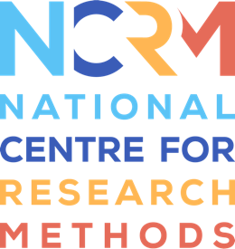
Fundamentals of Inclusive Research

Transcript Video 2 ‘Relevance’
Full video, see: https://www.ncrm.ac.uk/resources/online/all/?id=20841

When we talk about relevance, it's all about asking ourselves: if someone saw your research materials, questions, and the data you're gathering, would they see it as something important and relevant to them.
Your research should help address real-world issues, but let's dive a bit deeper. There might be people in your target population who might have different needs, and could benefit from a well-thought-out approach that encourages them to take part.
For example, to improve intervention adoption and outcomes in an osteoarthritis study a team at the University of Leeds created a peer-support program with people experiencing socioeconomic disadvantage, so participants are supported by people who can relate to them and their situation.
The more lenses you can look at your research through, whether that be different academic backgrounds, cultural experiences, or life stories, the more you can understand how your research is perceived by different people.
These conversations can shape your research proposal, refine study questions and ensure you include outcomes that are most important to the communities you want to help. You might be surprised to find that research questions you believe are vitally important, aren’t the ones most important to those you wish to recruit.
Involving different people is about welcoming a critical friend, having genuine conversations and learning from each other. The People’s Trial, invited members of the public to develop a research question, decide the eligibility criteria, data collection methods and how to report the findings. the researchers were merely there to enact the major decisions made by the public.
It's an extreme example, but it shows how involving the community can make research more relevant and impactful.
Relevance can be enhanced in various ways. For example, researchers on the INCLUDED project trained community partners to run focus groups so that participants could comfortably share their feelings about the collection of their ethnicity data with someone who shares their cultural background.
Tailoring your research to communities within your target population can help ensure your work is embraced by groups that have previously been underrepresented. For example, if you want certain people to engage with your work, use language, imagery, and colours that resonate with them. A simple exercise would be to search charities or organizations commonly associated with these groups and see if there is imagery you could mirror in your research advertisement. In doing this your research could have a greater impact on the diversity of your target population.

National Centre for Research Methods (NCRM)
Social Sciences
Murray Building (Bldg 58)
University of Southampton
Southampton SO17 1BJ
United Kingdom
Web www.ncrm.ac.uk
Email info@ncrm.ac.uk
Tel +44 23 8059 4539
Twitter @NCRMUK

